Asymmetric DCC correlation: GBPUSD and NZDUSD
Method 10 / GARCH(1,1) + Cappiello-Engle-Sheppard ADCC / Alpari D1 full available history

Study setup
Logical pair: GBPUSD , NZDUSD
Broker symbols: GBPUSD_i , NZDUSD_i
Snapshot: 2026-11-03_majors_alpari_D1
Timeframe: D1
Matched return window: 1999-01-05 to 2026-11-02 (UTC bar dates)
Matched return count n: 7203
Dropped unfinished last bar dated 2026-11-03 UTC after a tick-volume check against the prior complete day.
GBPUSD GARCH(1,1): mu=0.000019, omega=0.004049, alpha=0.055534, beta=0.931977
NZDUSD GARCH(1,1): mu=0.000000, omega=0.004924, alpha=0.040666, beta=0.950360
ADCC: a=0.018184, b=0.978015, g=0.005602, a+b+g/2=0.999000
Nested DCC (g=0): a=0.021226, b=0.977008
Negative shock: n = min(z, 0) in broker quote direction (not inverted)
Burn-in ignored in path summaries and chart: first 60 updates
Complete matched rows (Excel): GBPUSD-NZDUSD_ADCC_D1.xlsx
Complete matched rows (HTML table): GBPUSD-NZDUSD_ADCC_D1_data.html

Method carried forward
Asymmetric DCC extends Engle DCC with an extra term on joint negative standardised shocks. Each matched daily log return of close, ln(close_t / close_t-1), is first filtered by a constant-mean GARCH(1,1). Then z = residual / sigma and n = min(z, 0). The Cappiello-Engle-Sheppard recursion uses A = (1-a-b) Q_bar - g N_bar with N_bar = mean(n n'). Quotes are not inverted, so a negative shock is a negative log return in the broker quote. Nested symmetric DCC (g = 0) is fit on the same z path for comparison. Constraints: a,b,g >= 0 and a + b + g/2 < 1. Path summaries ignore the first 60 updates. The headline is latest ADCC rho. Pearson r is a side check only. This is not a cause, lead, or trading signal.

Results
Latest ADCC rho: 0.669427
Latest nested DCC rho: 0.667040
Post-burn-in ADCC path (n=7143): mean=0.501956, median=0.504899, min=0.062483, max=0.804799, std=0.172141
Share of post-burn-in days with |rho| >= 0.4: 70.71%; |rho| >= 0.7: 15.09%
Same-sample Pearson r: 0.530079
ADCC minus r: 0.139348
ADCC minus nested DCC: 0.002387

Conclusion
Over 7203 matched daily log-return rows for GBPUSD and NZDUSD (broker quote directions unchanged), latest ADCC rho is 0.6694 (positive, moderate conditional linear link in this sample) with fitted a=0.0182, b=0.9780, g=0.0056. Nested symmetric DCC latest rho is 0.6670 (ADCC minus DCC = 0.0024). After a 60-day burn-in, path mean is 0.5020 and std is 0.1721. Same-sample Pearson r is 0.5301 (ADCC minus r = 0.1393). This does not establish cause, lead-lag, or a lasting trading rule.

Charts
Daily closes

Daily log returns
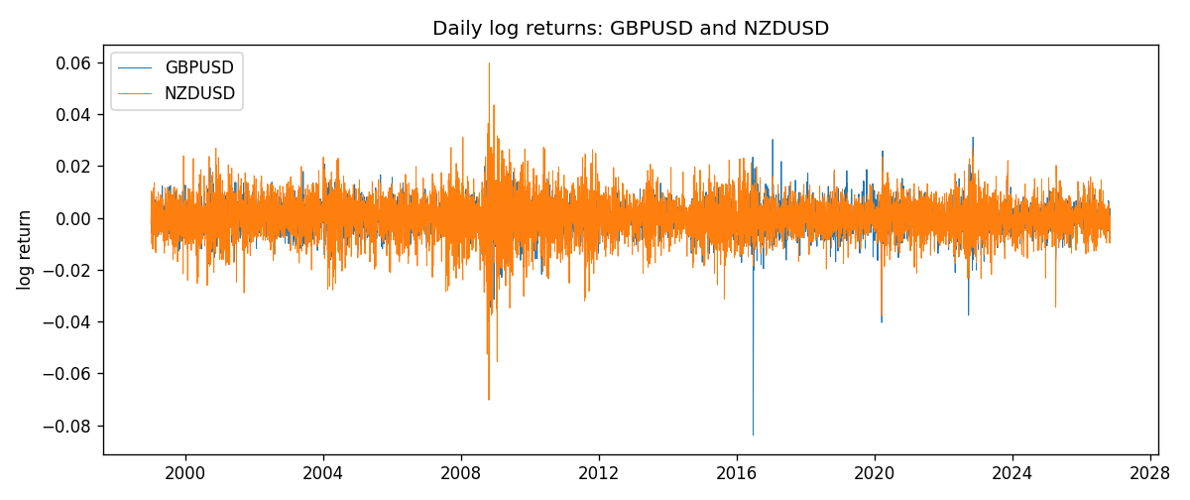
ADCC rho path with nested DCC and Pearson r
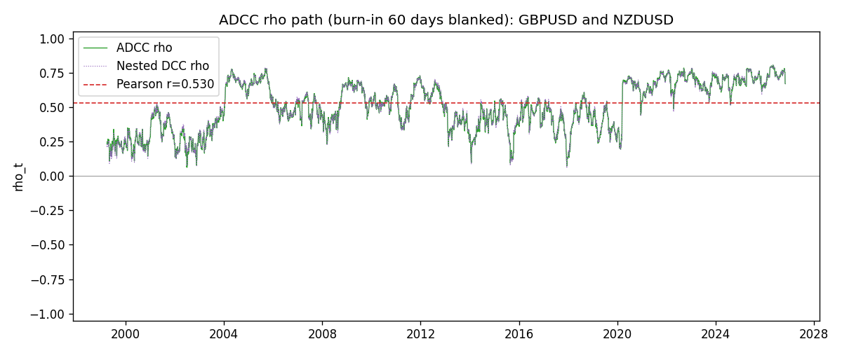

Data report
Every matched row that entered the ADCC recursion is stored in the sibling Excel workbook named GBPUSD-NZDUSD_ADCC_D1.xlsx. Embedding all rows as a Word table is impractical at this length; the Word file holds the column list, column summaries, and the first and last 15 matched rows.
Columns: time, GBPUSD_open, NZDUSD_open, GBPUSD_high, NZDUSD_high, GBPUSD_low, NZDUSD_low, GBPUSD_close, NZDUSD_close, GBPUSD_tick_volume, NZDUSD_tick_volume, GBPUSD_spread, NZDUSD_spread, GBPUSD_real_volume, NZDUSD_real_volume, GBPUSD_log_return, NZDUSD_log_return, GBPUSD_sigma, NZDUSD_sigma, GBPUSD_z, NZDUSD_z, GBPUSD_n, NZDUSD_n, q11, q22, q12, rho_adcc, rho_dcc
Column summaries (matched calculation rows)
column | count | mean | std | min | 25% | 50% | 75% | max
GBPUSD_open | 7203 | 1.5160351 | 0.21820856 | 1.06854 | 1.32502 | 1.51126 | 1.63163 | 2.1066
NZDUSD_open | 7203 | 0.65617721 | 0.10827592 | 0.3913 | 0.59107 | 0.6683 | 0.72469 | 0.88218
GBPUSD_high | 7203 | 1.5223294 | 0.21877071 | 1.08366 | 1.3298 | 1.51797 | 1.63833 | 2.1161
NZDUSD_high | 7203 | 0.66009189 | 0.10877133 | 0.3961 | 0.594565 | 0.67188 | 0.729235 | 0.88421
GBPUSD_low | 7203 | 1.5097156 | 0.21743942 | 1.03518 | 1.319525 | 1.50315 | 1.62431 | 2.0983
NZDUSD_low | 7203 | 0.65248767 | 0.1078698 | 0.3897 | 0.587935 | 0.66402 | 0.72082 | 0.87988
GBPUSD_close | 7203 | 1.5161019 | 0.21816437 | 1.06879 | 1.32515 | 1.51122 | 1.63196 | 2.1065
NZDUSD_close | 7203 | 0.65624807 | 0.10827144 | 0.3907 | 0.591395 | 0.6683 | 0.724915 | 0.8822
GBPUSD_tick_volume | 7203 | 94800.961 | 153533.35 | 62 | 9991 | 52873 | 91772.5 | 1273370
NZDUSD_tick_volume | 7203 | 68552.383 | 123030.52 | 16 | 5500.5 | 33815 | 58467.5 | 1127682
GBPUSD_spread | 7203 | 26.976121 | 19.194852 | 0 | 11 | 20 | 50 | 50
NZDUSD_spread | 7203 | 30.373178 | 25.676979 | 0 | 9 | 17 | 50 | 80
GBPUSD_real_volume | 7203 | 3.5551025e+09 | 8.4426509e+10 | 0 | 0 | 0 | 0 | 2.4038164e+12
NZDUSD_real_volume | 7203 | 1.6657093e+10 | 8.4881524e+10 | 0 | 0 | 0 | 0 | 2.705649e+12
GBPUSD_log_return | 7203 | -2.372e-05 | 0.00564203 | -0.08388241 | -0.00312422 | 3.221e-05 | 0.0031735 | 0.03112653
NZDUSD_log_return | 7203 | 5.29e-06 | 0.00764545 | -0.07027433 | -0.00426254 | 0.00021291 | 0.00457891 | 0.05966839
GBPUSD_sigma | 7203 | 0.00539261 | 0.00169297 | 0.00300535 | 0.00447645 | 0.00503236 | 0.00577524 | 0.02201778
NZDUSD_sigma | 7203 | 0.00728856 | 0.00216942 | 0.00438969 | 0.00595858 | 0.00670876 | 0.00804031 | 0.02523043
GBPUSD_z | 7203 | -0.00685012 | 1.000022 | -10.30555 | -0.6000551 | 0.00290134 | 0.60658892 | 4.9462534
NZDUSD_z | 7203 | -0.00236753 | 1.0000747 | -5.6200599 | -0.63176558 | 0.03249755 | 0.64626906 | 4.2140658
GBPUSD_n | 7203 | -0.3863291 | 0.60997753 | -10.30555 | -0.6000551 | 0 | 0 | 0
NZDUSD_n | 7203 | -0.38953342 | 0.61549575 | -5.6200599 | -0.63176558 | 0 | 0 | 0
q11 | 7203 | 1.001678 | 0.22135106 | 0.51454133 | 0.88941864 | 0.97663787 | 1.0676999 | 3.8307622
q22 | 7203 | 1.0017062 | 0.19037366 | 0.61061306 | 0.87257073 | 0.96790678 | 1.0866884 | 2.3207069
q12 | 7203 | 0.50220361 | 0.20665356 | 0.05863617 | 0.35272058 | 0.49987614 | 0.63363632 | 1.3737824
rho_adcc | 7203 | 0.49983046 | 0.17317002 | 0.06248254 | 0.37064683 | 0.50189084 | 0.66127618 | 0.80479874
rho_dcc | 7203 | 0.50060876 | 0.17388969 | 0.05761194 | 0.37460701 | 0.50508974 | 0.6606996 | 0.80695084
First 15 matched rows (selected columns)
time | GBPUSD_log_return | NZDUSD_log_return | GBPUSD_z | NZDUSD_z | GBPUSD_n | NZDUSD_n | q11 | q22 | q12 | rho_adcc | rho_dcc
1999-01-05 | -0.0028966287 | -0.0018597736 | -0.71496668 | -0.31623 | -0.71496668 | -0.31623 | 1 | 1 | 0.50208529 | 0.50208529 | 0.50208529
1999-01-06 | -0.00060452184 | 0.0020455609 | -0.15409249 | 0.35325207 | -0.15409249 | 0 | 0.9910548 | 0.98122276 | 0.49655645 | 0.50354233 | 0.50365566
1999-01-07 | -0.002118709 | 0.0062963171 | -0.53971206 | 1.1040905 | -0.53971206 | 0 | 0.97071218 | 0.96274881 | 0.48478148 | 0.50146923 | 0.5016325
1999-01-08 | -0.0058954193 | -0.00055396548 | -1.5130269 | -0.096495426 | -1.5130269 | -0.096495426 | 0.9571806 | 0.96457825 | 0.46341963 | 0.48229055 | 0.48012536
1999-01-11 | -0.0056851331 | 0.010290425 | -1.400514 | 1.8226444 | -1.400514 | 0 | 0.99147002 | 0.9444226 | 0.45683574 | 0.47210337 | 0.47131197
1999-01-12 | 0.0022657001 | -0.0053157489 | 0.53442702 | -0.89744976 | 0 | -0.89744976 | 1.0172083 | 0.98489579 | 0.40050714 | 0.40013836 | 0.39078063
1999-01-13 | 0.0091330396 | -0.0099742238 | 2.2004334 | -1.6862794 | 0 | -1.6862794 | 1.0009194 | 0.9832296 | 0.38311228 | 0.38618824 | 0.37614794
1999-01-14 | 0.0019376331 | -0.00018564931 | 0.41860486 | -0.03026727 | 0 | -0.03026727 | 1.0678394 | 1.0300788 | 0.30734933 | 0.29305158 | 0.27237535
1999-01-15 | -0.0017558204 | -0.00074294208 | -0.39503468 | -0.12319571 | -0.39503468 | -0.12319571 | 1.0484303 | 1.0082835 | 0.30049348 | 0.29226308 | 0.27202295
1999-01-18 | 0.0012112405 | -0.0018597736 | 0.27071674 | -0.31390853 | 0 | -0.31390853 | 1.0299733 | 0.98730647 | 0.29517633 | 0.29271336 | 0.27296522
1999-01-19 | 0.0018745281 | 0.0018597736 | 0.43071172 | 0.31884794 | 0 | 0 | 1.009543 | 0.9687735 | 0.28727323 | 0.29048361 | 0.27105021
1999-01-20 | -0.0049053846 | 0.0040793678 | -1.1642025 | 0.71058044 | -1.1642025 | 0 | 0.99160241 | 0.95015278 | 0.28358636 | 0.29215937 | 0.2736198
1999-01-21 | 0.0031518998 | 0.0040627941 | 0.72982188 | 0.71275869 | 0 | 0 | 1.0029217 | 0.93927424 | 0.2624406 | 0.27039664 | 0.25048462
1999-01-22 | 0.0024781662 | -0.012051689 | 0.57764571 | -2.1293528 | 0 | -2.1293528 | 0.99143885 | 0.92869125 | 0.26626143 | 0.27748507 | 0.25954068
1999-01-25 | 0.0012066366 | -0.0035504102 | 0.28282845 | -0.58498292 | 0 | -0.58498292 | 0.97659048 | 1.0169522 | 0.23817299 | 0.23899345 | 0.22015966
Last 15 matched rows (selected columns)
time | GBPUSD_log_return | NZDUSD_log_return | GBPUSD_z | NZDUSD_z | GBPUSD_n | NZDUSD_n | q11 | q22 | q12 | rho_adcc | rho_dcc
2026-10-13 | 0.0036434319 | 0.0047326165 | 0.98710975 | 0.96078954 | 0 | 0 | 0.75239475 | 0.73453067 | 0.56921808 | 0.76568623 | 0.75853981
2026-10-14 | -0.0049164679 | -0.0037306483 | -1.3334965 | -0.75444076 | -1.3334965 | -0.75444076 | 0.7544523 | 0.73599689 | 0.57408107 | 0.77040544 | 0.76447813
2026-10-15 | 0.0065976411 | 0.0047634855 | 1.7261505 | 0.96619512 | 0 | 0 | 0.78104314 | 0.73418363 | 0.5855213 | 0.77321957 | 0.76716894
2026-10-16 | 0.0037592051 | 0.0057501001 | 0.92511492 | 1.1613568 | 0 | 0 | 0.81893321 | 0.73584689 | 0.60310718 | 0.77692041 | 0.77194962
2026-10-19 | -0.0017500314 | 0.0018917133 | -0.43664554 | 0.37727357 | -0.43664554 | 0 | 0.81737226 | 0.7450238 | 0.60951599 | 0.78107022 | 0.77711053
2026-10-20 | 0.0055923442 | 0.0037199341 | 1.3987011 | 0.75113129 | 0 | 0 | 0.80481827 | 0.73206175 | 0.59325192 | 0.77288767 | 0.76840496
2026-10-21 | 0.0012476328 | 0.0030923331 | 0.29861445 | 0.62646716 | 0 | 0 | 0.82357942 | 0.72705575 | 0.59944498 | 0.77466285 | 0.77077714
2026-10-22 | 0.00022396082 | -0.0033035227 | 0.050807771 | -0.67397916 | 0 | -0.67397916 | 0.8079754 | 0.71903697 | 0.58979951 | 0.77380179 | 0.76999607
2026-10-23 | -0.0021146949 | 0.0030929853 | -0.54083467 | 0.63425623 | -0.54083467 | 0 | 0.79113992 | 0.71486278 | 0.57634174 | 0.76637633 | 0.76322905
2026-10-26 | -0.0024340661 | -0.0028993932 | -0.62995226 | -0.59849641 | -0.62995226 | -0.59849641 | 0.78158507 | 0.70729062 | 0.55756496 | 0.74990871 | 0.74536499
2026-10-27 | -0.0023648393 | -0.00026399852 | -0.61816342 | -0.054961858 | -0.61816342 | -0.054961858 | 0.77472207 | 0.70109002 | 0.55440643 | 0.75226075 | 0.74752485
2026-10-28 | 0.0015771808 | -0.0097283914 | 0.40804693 | -2.0514257 | 0 | -2.0514257 | 0.76765996 | 0.68657751 | 0.54315758 | 0.74816367 | 0.74394799
2026-10-29 | 0.0035881935 | 0.00062190714 | 0.94953358 | 0.12255567 | 0 | 0 | 0.75469152 | 0.77241194 | 0.51612664 | 0.67600056 | 0.6740061
2026-10-30 | 0.0013450605 | 0.00019537668 | 0.35089628 | 0.039033029 | 0 | 0 | 0.75537531 | 0.75653269 | 0.5070273 | 0.67071204 | 0.66822256
2026-11-02 | 0.0010971256 | -0.0025962955 | 0.29008718 | -0.52782336 | 0 | -0.52782336 | 0.74188823 | 0.74075712 | 0.49626099 | 0.66942663 | 0.66703997

